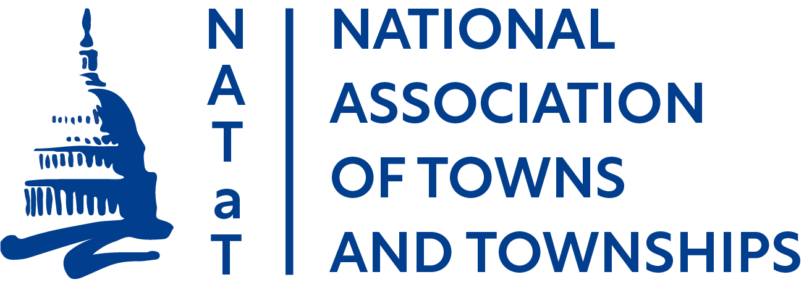

2024 NATaT Federal Platform
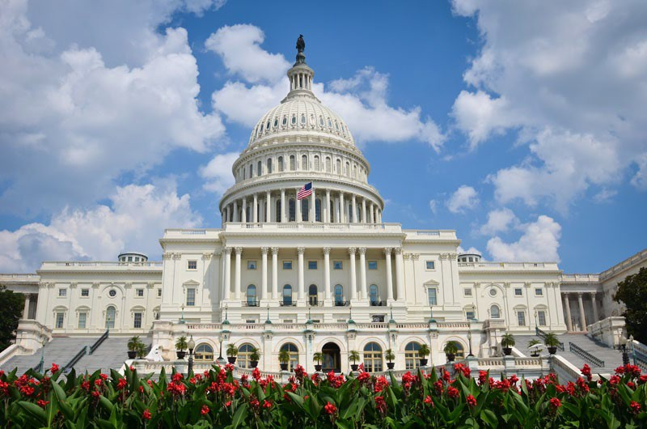

www.natat.org

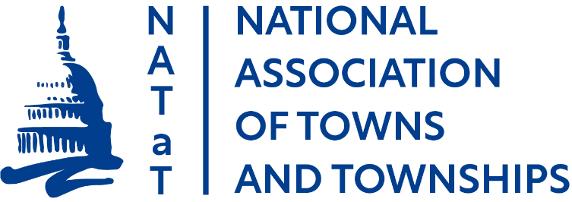

2024 Federal Priorities

Infrastructure

Transportation

- NATaT supports the U.S. Department of Transportation’s (USDOT’s) Off-System Bridge program, which funds state and local bridges that are not on the Federal-aid Highway system. However, many of the nation’s “bridges” that need repair and replacement are not eligible because they do not meet the federal definition of a bridge. Federal regulations define a bridge as a structure having a span greater than 20 feet (23 CFR 661.17(a)(1)). NATaT supports a carve-out of the off-system bridge program to include structures that are 10 to 20 feet, which states must distribute through a competitive process.

- In future authorization bills, NATaT wants to ensure that any effort to impose vehicle miles traveled fees considers the limited transportation options for rural residents and the resulting need to use their vehicles to access work and daily services.

- NATaT supports federal efforts to invest in electric vehicle (EV) infrastructure. However, we are concerned about the lack of access to this infrastructure in our more rural areas. As such, NATaT supports Congressional and Administration efforts to ensure funding for EV infrastructure is available to rural communities.

- NATaT opposes efforts to increase the national truck weight limit on the federal highway system, and efforts to allow longer, wider double- and triple-trailer trucks on federal highways.

- NATaT encourages the USDOT to prioritize funding projects in rural areas. NATaT also wants to ensure that DOT understands the reality of the current “rural” definition, which is an area that is outside an urbanized area with a population of less than 200,000. To our nation’s towns and townships, 200,000 is not “rural.”

- NATaT supports the Rebuilding Rural Roads Act and Protecting Infrastructure Investments for Rural America Act that address DOT’s definition of “rural” in the Rural Surface Transportation Grant Program.

- NATaT supports efforts to increase the federal volunteer driver mileage reimbursement (14¢/mile) to equal the federal business driver mileage reimbursement (65.5¢/mile).

Farm Bill

NATaT supports a Rural Development Title that promotes economic growth and stability by investing in our nation’s rural infrastructure, incentivizes regional collaboration, and ensures the success of our next generation of farmers. We support federal efforts to connect rural American communities, homes, farms, businesses, first responders, educational facilities, and healthcare facilities to reliable and affordable high-speed internet services.

Telecommunications and Cybersecurity
- NATaT supports federal efforts to ensure that all locations have access to high-speed broadband with a primary focus on deployment in non-urban, rural areas where access is the most limited. Congress and the Administration should prioritize increased funding for broadband infrastructure deployment to both unserved and underserved areas and support federal programs that benefit satellite internet services that can provide universal broadband access, especially in more rural or remote areas.
- NATaT supports federal efforts to ensure coordination and planning between state and local governments that maximize the efficient and effective use of federal funds to expand broadband access in unserved and underserved rural areas.

- NATaT supports federal efforts to streamline broadband infrastructure deployment without preempting local control over public rights-of-way, permitting, and siting processes – tenets of a community’s right to self-govern.

- NATaT supports federal efforts to reform the Universal Service Fund contribution mechanisms that will create sustainable funding for the Connect America Fund, Lifeline, Schools and Libraries, and Rural Health Care programs and ensure the availability and affordability of high-speed broadband access.

- NATaT supports federal efforts to incentivize broadband adoption including extending the Affordable Connectivity Program and creating a sustainable funding option for its long-term support.

- NATaT opposes federal efforts that restrict local governments, cooperatives, and utilities from providing broadband services.

- NATaT supports federal efforts to improve the accuracy of the Federal Communication Commission’s National Broadband Map, including exercising Congressional oversight of the Commission’s rolling challenge process and enforcement actions levied against Internet Service Providers that provide inaccurate broadband availability data.

- NATaT supports federal efforts to provide technical assistance and funding to local governments to mitigate cybersecurity risks.

- NATaT supports the efforts of the Rural Broadband Caucus in both the House and Senate to facilitate discussion, educate Members of Congress, and develop policy solutions to close the digital divide in rural America.

Volunteer First Responders

NATaT supports Congressional efforts to establish incentive programs to recruit and retain volunteer first responders. Volunteer firefighters alone save communities of all sizes $129 billion a year, and represent 71% of all firefighters in the U.S. Of the total number of volunteer firefighters, 95% service communities with a population of 25,000 or less.

- NATaT supports the Volunteer First Responder Housing Act that would expand existing federal housing assistance programs to qualified volunteer first responders.

Unfunded Mandates and Federal Preemption

- The Department of Labor is revising the Fair Labor Standards Act’s overtime rule’s executive, administrative, and professional (EAP) exemptions. The rule will increase the minimum salary to be overtime-exempt from $35,568 to $55,068 (or $684 to $1.059/week), and further increases will adjust to inflation without regard to regional cost-of-living differences. While NATaT supports increased pay for extra work, this steep increase will severely impact local government budgets across the country.

- NATaT strongly supports legislation that would require the federal government to provide adequate and necessary funding sufficient to implement and administer any mandate imposed on local government, including the Financial Data and Transparency Act that requires local governments that receive municipal securities to adhere to new financial data standards and put their financial information in machine-readable format. NATaT opposes any expansion of these financial reporting requirements to federal loan and grant programs.

- Local authority must be preserved. NATaT opposes any effort by the federal government to preempt local authority, including zoning and land use decisions.

- NATaT supports a common-sense definition of the “Waters of the U.S.” rule without unnecessarily expanding the jurisdiction of the Clean Water Act.

- As mentioned in the “Broadband” section of the platform, NATaT supports preserving long-standing local zoning authorities in the deployment of emerging technologies, like small cell 5G. That authority is essential to protecting the safety of our residents.

Federal Funding

- NATaT supports efforts to control federal spending but supports increased, or at least level funding for those federal programs that promote local economic development, create jobs, and generate tax revenues for all levels of government. They include USDA’s Rural Development programs; FEMA’s State and Local Programs, particularly Fire Act Grants; Economic Development Administration programs; and National Telecommunications and Information Administration broadband-related programs.

- NATaT supports continued disbursement of Bipartisan Infrastructure Law funding to local governments as Congress authorized, and efforts to ensure those funds reach all local governments, regardless of size.

- NATaT urges Congress to authorize reasonable fees to recapture expenses for the provision of local government services to federal facilities and lands.

- NATaT supports budget allocation policies that are fair to towns and townships. A disproportionate amount of federal funds is directed to larger metropolitan communities. Notably, larger communities have significant needs, but so do our nation’s smaller communities. Allowing smaller local governments to access funding directly, and in the same manner as large municipalities, will enhance job creation and economic development in communities throughout the country. NATaT supports direct funding for ALL units of local government as included in the American Rescue Plan Act (ARPA) (P.L. No. 117-2).

Tax

- NATaT supports preserving the tax-exempt status of municipal bonds that have helped build public infrastructure for more than 200 years. These bonds enable state and local governments to access necessary capital for critical infrastructure projects. NATaT also supports reinstating advance refunding bonds to allow a community to refinance a municipal bond and maintain the bond’s tax-exempt status.

- NATaT supports the efforts of the House Municipal Finance Caucus as a forum to discuss the opportunities and challenges for local governments to fund initiatives that strengthen our communities, and to advocate for bipartisan policies that enhance our access to the capital markets.

www.natat.org
For more information, contact NATaT Federal Director Jennifer Imo at 202.454.3947/jimo@tfgnet.com

www.natat.org
For more information, contact NATaT Federal Director Jennifer Imo at 202.454.3947/jimo@tfgnet.com

The National Association of Towns and Townships (NATaT) is the voice for more than 10,000 towns and townships across the country seeking to enhance the ability of smaller communities to deliver public services, economic vitality, and good government to their citizens. America’s towns and townships seek to partner with the federal government to ensure that public laws, policies, regulations, and resources support our role in fostering local democracy.

There are approximately 39,000 units of local government in the United States. Of that number, 85 percent serve communities with less than 10,000 people and nearly half have fewer than 1,000 residents. Approximately one quarter of all Americans live in rural areas, roughly the same percentage as live in central cities. NATaT was formed more than 40 years ago to provide those smaller communities a strong voice in Washington, D.C. NATaT’s purpose today, as it was then, is to champion pro-town and -township federal initiatives and to promote legislative and regulatory policies designed to strengthen smaller units of local government.

NATaT has developed a proactive federal agenda to ensure that the needs and interests of the nation’s smaller communities are reflected in all major federal statutory, regulatory, funding, and policy decisions made in Washington. NATaT is eager to work in collaboration with the other local government associations, the Administration, and Congress to achieve these goals.

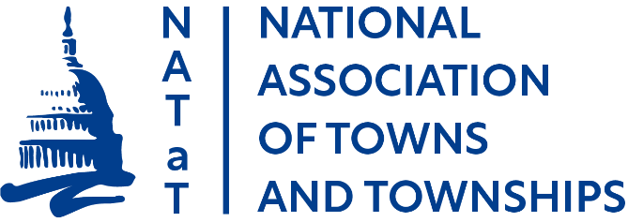
NATaT members include town and township officials represented by the following state associations:
Township Officials of Illinois Michigan Townships Association Minnesota Association of Townships
Association of Towns of the State of New York North Dakota Township Officers Association Ohio Township Association
Pennsylvania State Association of Township Supervisors
South Dakota Association of Towns and Townships
Wisconsin Towns Association

